Hoffman Estates Garden Club

PLANT SALE
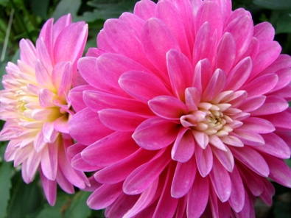
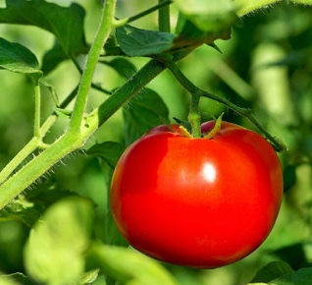

FRIDAY, JUNE 7, 2024
7:00 am – 1:00 pm
Schaumburg Farmers Market
190 S. Roselle Road, Schaumburg, IL
A portion of the sales will go to the Schaumburg Township Food Pantry

WE ARE OFFERING

A beautiful selection of sun and shade plants from members’ gardens or started from seed.

* Perennials * Herbs
* Annuals * Hostas
* Dahlias * Native Plants
* Grasses * Vegetables

** One Day Only - Sorry, no credit cards accepted **

www.hoffmanestatesgardenclub.com
email us at: hoffmangardenclub@gmail.com

